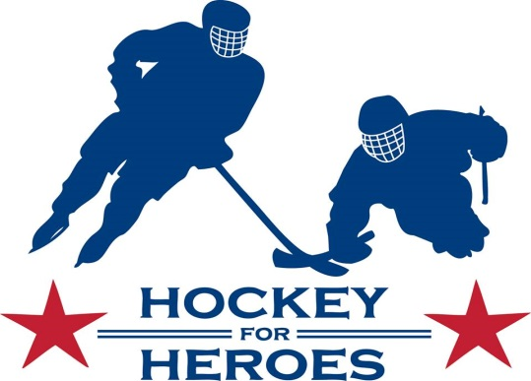

Sponsorship Opportunities

Hosted by Navy Youth Hockey, Hockey for Heroes is a 24-hour, ‘round-the-clock exhibition ice hockey tournament to raise awareness and provide financial support to USA Warriors Ice Hockey, DAV, Wounded Warrior Project, and local organizations providing services for disabled veterans. When you become a sponsor, you join Navy Youth Hockey in thanking America’s veterans for the great sacrifices they have made to protect our country and our freedom. Since 2014 -- its inaugural year -- Hockey for Heroes has raised over $500,000 for our heroes.
Hockey for Heroes 2024 will be held Friday, March 8th and Saturday, March 9th at the U.S. Naval Academy McMullen Ice Arena, Brigade Sports Complex, 64 Greenbury Point Road in Annapolis. Opening ceremonies begin at 7:00 p.m. Friday night. Our special guests include the USA Warriors, local and regional youth teams, high school and adult league teams. Spectator admission to the event is free.
Sponsorship Opportunities:

- $500 Hockey Fan Sponsorship: Promotion of sponsor with logo on Hockey for Heroes website and social media platforms. Opportunity to have a table at the 24-hour event, if appropriate and approved by the USNA and NYH Boards. We will include your logo on all event signage and the event program.

- $1,000 Warrior Sponsorship: Receives all aspects of Hockey Fan sponsorship, plus special recognition during the Opening Ceremony. We will hang a banner you provide at the rink, visible to all players and spectators.

- $2,500 Hero Sponsorship: Receives all aspects of Warrior sponsorship, plus on-ice remarks during the Opening Ceremony.

- $5,000 Hat Trick Sponsorship: Receives all aspects of Hero sponsorship, plus reserved seating for up to 4 guests during the Opening Ceremony and refreshments with our guests of honor.

- $10,000 Stanley Cup Sponsorship: Exclusive sponsor receives all aspects of Hat Trick sponsorship, plus reserved seating for up to 6 guests during the Opening Ceremony and refreshments with our guests of honor.

Navy Youth Hockey Association, Inc. is a 501(c)(3) charitable organization. Donations made to the organization are tax deductible to the fullest extent of the law. We have not provided you with any goods or services in exchange for this contribution. The NYHA, Inc.’s federal tax number is 61-1529098.

1290 Bay Dale Drive, #268 Arnold, MD 21012 NavyYouthHockey.org NYHHockeyforHeroes.org

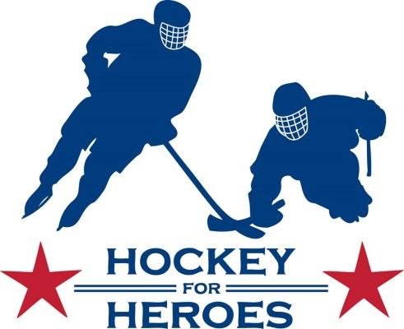

Commitment Form

Company Contact: Ph #:

Company Address:

Yes, I will support through sponsorship (list sponsorship level or amount):

Company name as you want it recognized:

Enclosed check payable to: Navy Youth Hockey, Inc. (please write Hockey for Heroes in Memo)

OR Please charge my credit card: Mastercard: Visa: Amex: Disc:

Name as it appears on card:

Card Number: Exp Date:

Email:

Please return to: Hockey for Heroes
Attn. Amy Hitt
377 Ridge Road
Annapolis, MD 21401

Navy Youth Hockey Association, Inc. is a 501(c)(3) charitable organization. Donations made to the organizations are tax deductible to the fullest extent of the law. We have not provided you with any goods or services in exchange for this contribution. The Navy Youth Hockey Association, Inc.’s federal tax number is 61-1529098.

